

SIMATS ENGINEERING

Saveetha Institute of Medical and Technical Sciences Chennai- 602105
Student Name: SAI TEJESH Reg. No.:192424342
Course Code: DSA0423 Slot: D
Course Name: DSA0423 - Fundamentals of Data Science for NLP
Course Faculty: Dr. Senthilvadivu.S

Project Title:Design and Evaluation of Bayesian-Based Portfolio Optimization Models Using Financial Market Data

Module Photographs:
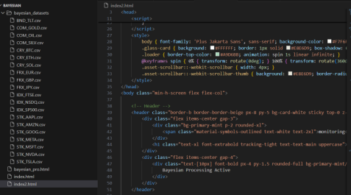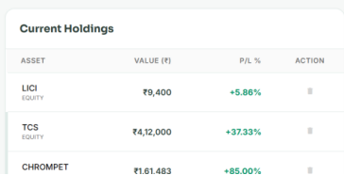
Project Description:
contribution to the Project – Data Collection and Uncertainty ModelingIn this module, our primary contribution was designing and implementing a structured data acquisition and uncertainty modeling framework to support Bayesian portfolio optimization. We were responsible for identifying relevant financial data sources, collecting historical market data, preprocessing it, and preparing it for probabilistic modeling.To collect the data, we gathered historical price information for multiple asset classes including equities, gold, and real estate investment instruments. Stock market data was sourced from publicly available financial platforms such as National Stock Exchange of India and Bombay Stock Exchange. Gold price data was obtained from commodity market records, while real estate trend data was referenced from published market indices and financial reports.

Student Signature Guide Signature

